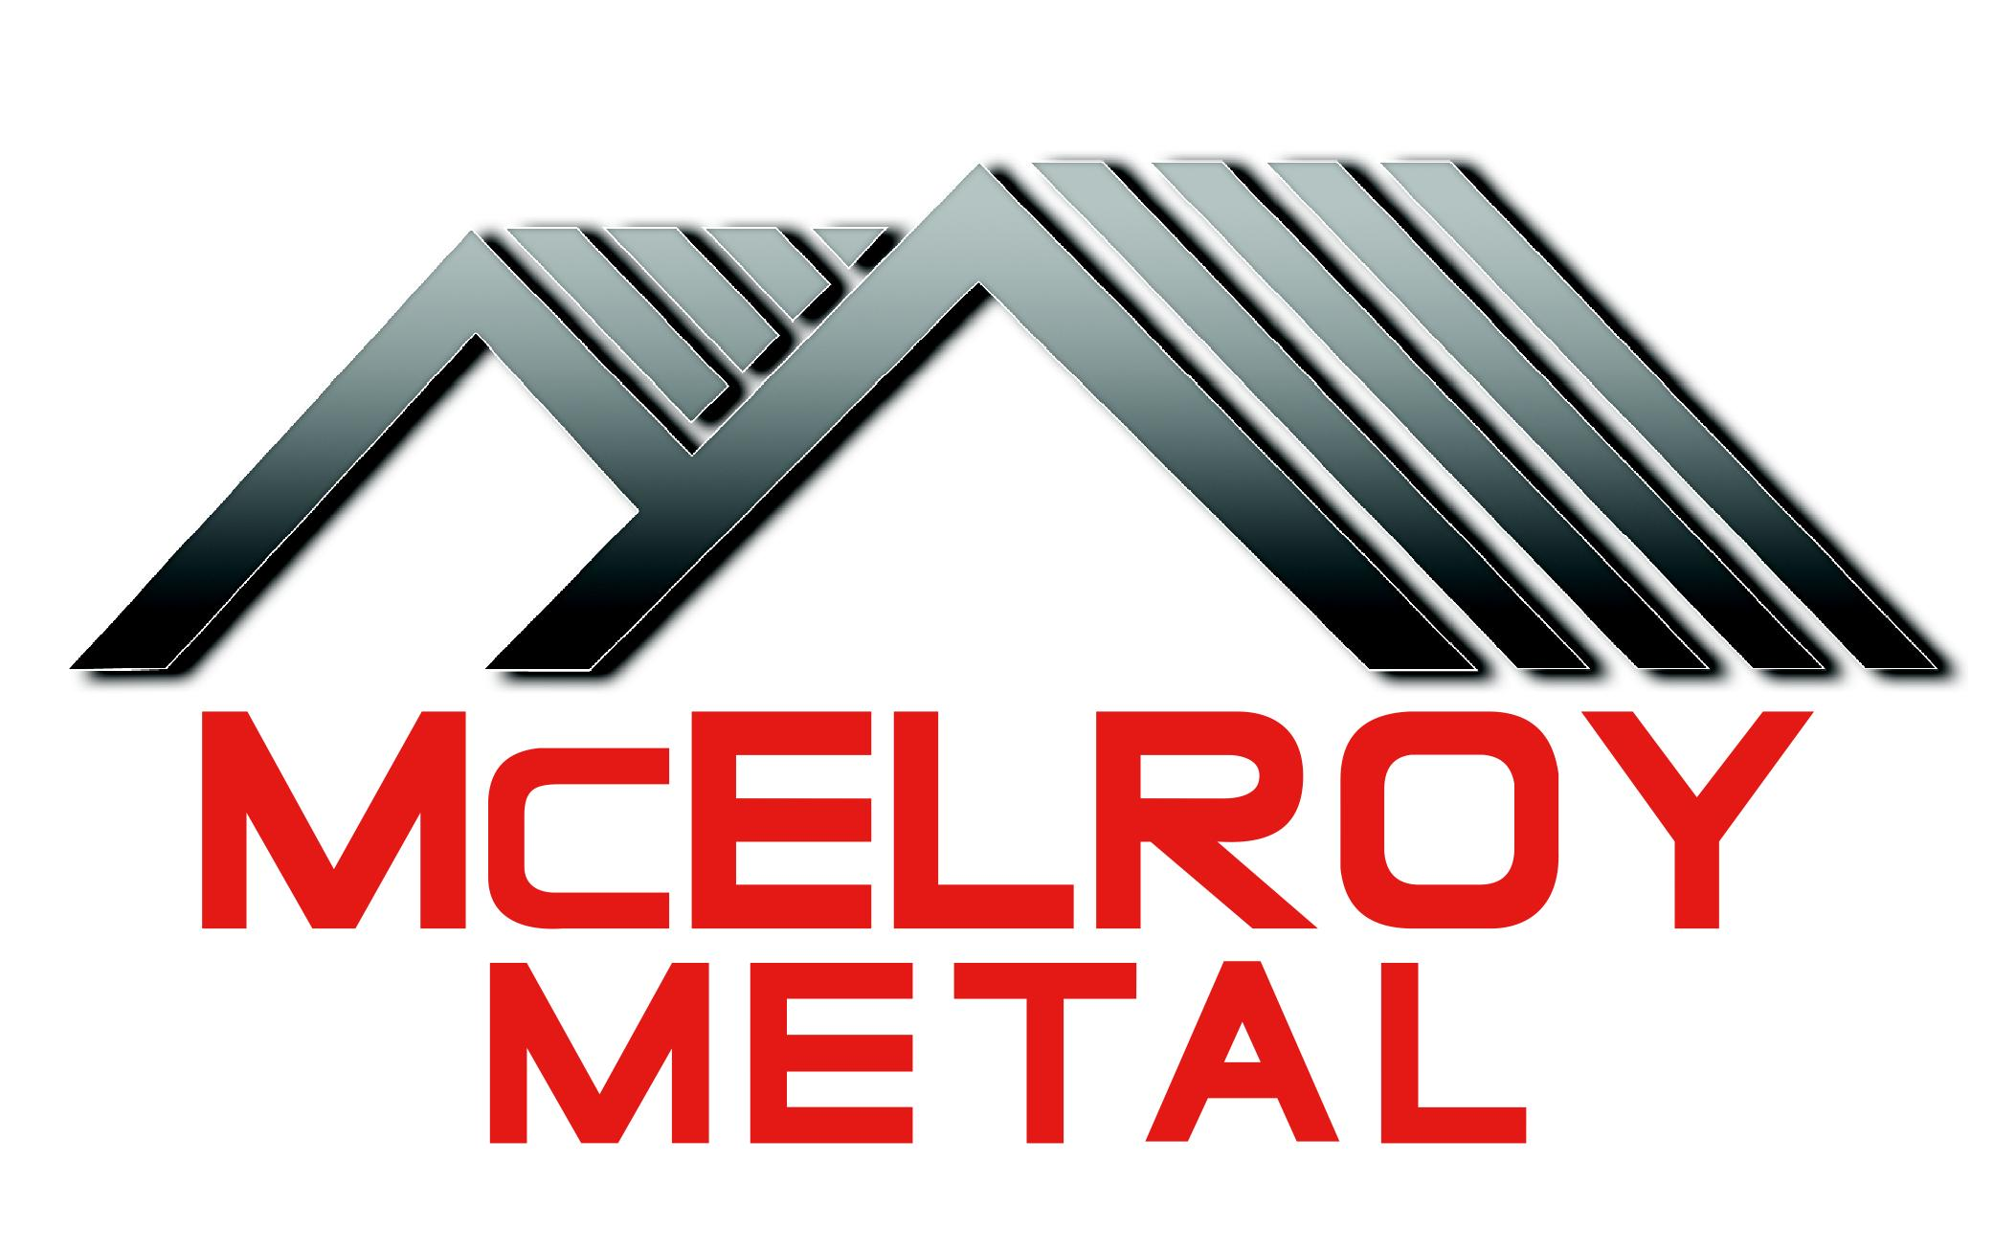

238T
Aluminum
Standing Seam Metal Roof System (SSMRS)

Text in red are instructions to the specifier and should be deleted.
Text in blue are choices that need to be made, with those not selected, deleted.

McElroy Metal, Inc.
1500 Hamilton Road
Bossier City, LA 71111
Phone: (800) 562-3576
Phone: (318) 747-8097
Fax: (318) 747-8099
Email: info@mcelroymetal.com
www.mcelroymetal.com
April 15, 2013
SECTION
Section 07 41 13

PART 1 GENERAL
- SUMMARY
  - SECTION INCLUDES
    - Standing-seam metal roof panels, including trim and accessories
    - RELATED SECTIONS
      - Section 05 31 23 - Steel Roof Decking
      - Section 07 22 00 - Roof and Deck Insulation
      - Section 07 62 00 - Sheet Metal Flashing and Trim
      - Section 07 72 00 - Roof Accessories
      - Section 07 92 00 - Joint Sealants
- REFERENCES
  - AISI S-100 – North American Specification for the Design of Cold-Formed Steel Structural Members
  - ASCE-7: American Society of Civil Engineers -Minimum Design Loads for Buildings and Other Structures; version adopted by local Building Code authority having jurisdiction.
  - ASTM B209 - Specification for Aluminum-Alloy Sheet and Plate
  - ASTM E1592 - Standard Test Method for Structural Performance of Sheet Metal Roof and Siding System by Uniform Static Air Pressure Difference
  - UL 580 - Tests for Uplift Resistance of Roof Assemblies
- ADMINISTRATIVE REQUIREMENTS
  - Pre-installation Meetings:
    - Schedule meeting to discuss roof project requirements, substrate conditions, manufacturer’s installation instructions, and manufacturer’s warranty requirements before start of work onsite.
    - Required attendees: Contractor, metal deck & roof installer, and any other subcontractors who have equipment penetrating the roof or Work that requires roof access or traffic.
- SUBMITTALS
  - Product Data: Manufacturer literature indicating product specifications, installation instructions, and standard construction details for specified products.
  - Shop Drawings: To be prepared by metal roof system manufacturer.
    - Submit roof plan showing panel layout, profiles, components, accessories, finish colors, gutters and downspouts as applicable.
      - Indicate layout of roofing panels and roof panel sizes, including custom fabricated roofing panels if indicated, indicate each trim condition.
      - Include details of each condition of installation, including the locations and types of fasteners, sealants and accessories. Indicate locations, gauges, shapes, and methods of attachment of all panels, accessories and trim.
      - Indicate products/materials required for construction activities of this section not supplied by manufacturer of products of this section.
      - Indicate locations of field applied sealant.
      - Indicate locations of field worked conditions.
    - Roof Panel Attachment:
      - Roof plan with wind uplift pressure calculations at field, corner and perimeter areas according to version of ASCE-7 referenced by locally-adopted Building Code and the authority having jurisdiction.
      - Roof plan indication roof clip spacing pattern at field, corner, perimeters and where panels are to be fixed from thermal movement.
      - Roof panel attachment plan must be stamped by licensed engineer in State in which project is constructed, certifying roof attachment meets local Building Code requirements for wind uplift.
  - Samples:
    - Submit two samples, 12" long, full width panel, showing metal gauge, and seam.
    - Two samples each for roof panel clip, bearing plate and clip fastener.
    - Submit color samples for Architect's selection.
    - Submit sample warranties:
      - Manufacturer Finish Warranty
      - Manufacturer Weathertightness Warranty complying with this Specification
      - Installer Warranty
  - Certificates:
    - Submit roof panel manufacturer's certification that fasteners, clips, backup plates, closures, roof panels and finishes meet the specification requirements.
    - Submit roof panel manufacturer’s certification that installer meets requirements to install roof system and is qualified to obtain required warranties.
  - Delegated Design Submittals: Submit engineering calculations indicating wind uplift pressure calculations according to local building code for project location with respect to appropriate Importance Factor, Exposure category and Safety Factor. Calculations shall be sealed by a professional engineer licensed to practice structural engineering in the state in which project is located.
  - Test and Evaluation Reports - Certified test results that indicate roof system meets or exceeds design and performance criteria. Testing to include:
    - ASTM E1592 - Manufacturers test data, signed and sealed by a registered professional engineer, substantiating that roof system will meet the allowable wind pressures using an appropriate Factor of Safety in accordance with AISI S-100.
  - Qualification Statements: For Manufacturer and Installer.
- CLOSEOUT SUBMITTALS
  - Operation and Maintenance Data: Manual indicating requirements and recommendations, to maintain the roof system in good working condition.
  - Warranty Documentation: Submit final warranties required in this section.
- QUALITY ASSURANCE
  - Qualifications:
    - Manufacturer Qualifications: Manufacturer shall have a minimum of ten years experience in the manufacturing of metal roof systems similar to those required for this project. Manufacturer must have a current installer training program.
    - Installer Qualifications: Installer ("roofer") to perform the work of this section shall have no fewer than 5 years of successful experience with the installation of metal roof systems similar to those required for this project. The installer shall be qualified by the roof panel manufacturer for installation of manufacturer-warranted systems.
  - Field Measurements: Prior to fabrication of panels, take field measurements of structure or substrates to receive panel system. Allow for trimming panel units, where final dimensions cannot be established prior to fabrication.
  - Mock-Ups: Install a 30 foot wide, quality control area of metal roofing, for review by the Architect. The Architect shall approve the quality of installation for the roof, prior to installing additional metal panels.
- DELIVERY, STORAGE AND HANDLING
  - Delivery and Acceptance Requirements: Deliver panels to jobsite properly packaged to provide protection against transportation damage. Panels too long to ship shall be site formed onto the roof by manufacturer’s factory personnel using manufacturer’s factory roll forming equipment.
  - Storage and Handling Requirements:
    - Exercise care in unloading, storing and erecting panels to prevent bending, warping, twisting, and surface damage.
    - Store all material and accessories above ground on well skidded platforms. Store under waterproof covering. Provide proper ventilation to panels to prevent condensation build-up between each panel.
    - Remove from site and replace panels which are damaged, or become water-stained during storage and handling.
- WARRANTIES
  - Manufacturer Warranties:

    - Panel Coating: Furnish manufacturer's 40-year warranty panel coating warranty covering cracking, checking, and peeling, and 30 year warranty covering fade and chalk.
    - Metal Roof Weathertightness Warranty:
      - Manufacturer’s (Choose One) [Joint] [Single Source] Weathertightness Warranty
        - Warranty term: (Choose One) [5] [10] [15] [20] years commencing on date of substantial completion.
        - Total manufacturer’s liability: (Choose One) [$0.20] [$1.50] [$3.00] [$5.00] [$7.00] [$14.00] [NRL (No Repair Limit)] / sq. ft.
        - Warranty must cover: (Choose all that apply) [Pipe and Curb Penetrations]; [Wind Speeds up to 75 mph]
          - (If “Pipe and Curb Penetrations” is chosen) Pipes must be centered in pan or a pipe curb must be used. Pipe must be flashed with an EPDM dektite.
          - (If “Pipe and Curb Penetrations” is chosen) Curbs must be all welded aluminum or stainless steel.
          - (If “Wind Speeds up to 75 mph” is chosen) Manufacturer must supply engineered installation drawings signed and sealed by an engineer registered in the state in which the project is located.
  - Installer Warranty: Installer to provide warranty agreeing to repair or replace metal roof panels, trim, or accessories that fails due to poor workmanship or faulty installation.
    - Warranty term: 2 years commencing on date of substantial completion.

PART 2 - PRODUCTS
- ROOF PANEL SYSTEM
  - Basis of Design: 238T by McElroy Metal, Inc. Bossier City, LA, or approved substitute.
  - Substitution Limitations
    - Requests for approval must be submitted in writing at least ten (10) days prior to bid date, and are accompanied by all related test reports and design calculations listed in section 1.4 and Design and Performance criteria Section 2.2.
    - Substitute manufacturers will be approved by written addendum to all bidders. Voluntary alternates will not be considered. Substitutions will not be permitted after the bid date of this project.
    - Roof panels proposed for substitution shall fully comply with specified requirements in appearance, assembly, and performance.
  - Product Options
    - Factory-formed panel, width of (Choose one) [18] [16] inches. Panels shall be symmetrical in design and shall be mechanically seamed with a field operated electric seaming machine approved by the manufacturer.
    - Minimum seam height 2 3/8 inches. Integral seam, double lock and snap together type panels are not acceptable
    - Seam cap matching panel finish with two rows of integral factory hot applied sealant. Sealant should not come in contact with clip, and clip should not require sealant to maintain a weathertight condition.
    - Aluminum-alloy sheet in accordance with ASTM B209.
      - Alloy: 3105 H14
      - Thickness: (Choose one) [0.032] [0.040] inches
    - Finish: Two coat coil applied, baked-on full-strength (70% resin, PVF2) fluorocarbon coating consisting of a nominal 0.25 mil dry film thickness primer, and a nominal dry film thickness of 0.7 - 0.8 mil color coat for a total 0.9 to 1.1 mil total system dry film thickness. Finish to be selected from manufacturer’s standard color selection. The back side of the material should be 0.25 mil primer and 0.25 mil polyester wash coat.
    - Roof panel system must allow individual roof panel removal and replacement from any point on the roof without damage to adjacent roof panel(s).
    - Roof panel system must be approved by manufacturer to be installed on slopes as low as ½:12.
    - Panels must be furnished and installed in continuous lengths from ridge to eave with no overlaps. Panels too long to ship will be manufactured on site using manufacturer’s employees and equipment.
    - Panel surface characteristics to be (Choose One) [Smooth] [Striated] [Minor Rib] [Plank and Pencil]
    - Manufacturer weathertightness warranty meeting requirements of this Section.
- PERFORMANCE/DESIGN CRITERIA
  - Thermal Movement: Metal Roofing system, including flashing, shall accommodate unlimited thermal movement without buckling or excess stress on the structure.
  - Roof panel and trim attachments will be designed to satisfy the requirements of the roof design (shown in shop drawings).
  - Maximum wind uplift capacity of roof system shall be determined using ASTM E 1592 test results, with an appropriate Factor of Safety in accordance with AISI S-100.
  - Panel system shall be designed in accordance with the local building code and ASCE7 for project location with respect to appropriate Exposure category, Importance Factor and Factor of Safety in accordance with AISI S-100.
  - Tested and listed by Underwriters Laboratories to comply with UL 580 for wind uplift Class 90 rating.
- ACCESSORIES
  - Panel Clip Screw - screw required in wind uplift rating requirements and design specification for application, with corrosion-resistant coating, in length necessary to penetrate substrate minimum 3/4 inch., as supplied by roof panel manufacturer.
  - Roof Panel Clip:
    - Intermittent Clip: 16 gauge galvanized steel, one-piece, designed to allow roof panel thermal movement and not contact roof panel cap, as supplied by roof panel manufacturer, meeting wind uplift requirements and design criteria of this section.
    - Intermittent Clip Bearing Plate: If required, in gauge, size and finish as supplied by and approved by roof panel manufacturer for use in roof panel manufacturer’s full assembly warranted systems.
    - Multi-Span Clip: as provided by roof panel manufacturer for full assembly warranted systems.
  - Trim and flashing will be of the same gauge and finish unless approved otherwise by the metal roof system manufacturer.
    - Ridge closures, consisting of metal channel surrounding factory precut closed cell foam, will not be secured through the field of the panel.
    - Trim will be installed specifically as displayed in the manufacturer provided shop drawings. Proposed changes must be approved in writing by the metal roof system manufacturer.
  - Concealed supports, angles, plates, accessories and brackets: gauge and finish as recommended, and furnished by manufacturer.
  - Accessory Screw: Size and screw type as provided by panel manufacturer for each use, with prefinished hex washer head in color to match panels where exposed to view.
  - Rivets: full stainless steel, including mandrel, in size to match application.
  - Field Sealant:
    - Exposed Sealant: Color coordinated urethane or polymer sealant as supplied by panel manufacturer.
    - Non-exposed Sealant: Non-curing, non-skinning, butyl tape or tube sealant as supplied by manufacturer.
  - Sealant Tape: non-drying, 100 percent solids, high grade butyl tape, as supplied by panel manufacturer, in sizes to match application.
  - Pipe Penetration Flashings: 20 year warranted flexible boot type, with stainless steel compression ring. Use silicone type at hot pipes.
  - Metal Roof Curbs: 0.063 minimum thickness welded aluminum, or 18 gauge minimum welded stainless steel, factory-insulated, with integral cricket, and designed to fit roof panel module, sized to meet application.

PART 3 - EXECUTION
- INSTALLERS
  - Must be certified and qualified by Manufacturer.
- EXAMINATION
  - Verification of Conditions
    - Ensure surfaces are ready for panel application.
    - Inspect and ensure surfaces are free from objectionable warp, wave, and buckle before proceeding with installation of pre-formed metal roofing.
    - Ensure substrate is ready to receive metal roofing. Report items for correction and do not proceed with metal roof panel system installation until resolved.
- PREPARATION
  - Install substrate boards, hat channels, purlins, or furring channels in accordance with manufacturer’s recommendations.
  - Coordinate Work, with installation of other associated Work, to ensure quality application.
  - Coordinate Work with installation of associated metal flashings and building walls.
  - Coordinate Work to minimize foot traffic and construction activity on installed finished surfaces.
  - Coordinate location of pipe penetrations to allow centering of pipe in panel.
  - Coordinate location of roof curbs, to allow proper integration with roof panel seams.
- INSTALLATION
  - Comply with and install roofing and flashings in accordance with all details shown on manufacturer’s approved shop drawings and manufacturer's product data, instructions, and installation manuals, within specified erection tolerances.
  - Install field panels in continuous lengths, without endlaps
  - Do not install panels damaged by shipment or handling.
  - Install intermittent clips with bearing plates, if required, and continuous clips, if required, according to the engineered design pattern in the field, perimeter, and corner areas of the roof.
  - Fix panels at location depicted on reviewed shop drawing(s).
  - Fold up pan of panel at ridge, hip and headwalls. Commonly referred to as breadpanning.
  - Allow for required panel clearance at penetrations for thermal movement.
  - Install concealed supports, angles and brackets as furnished by manufacturer to form complete assemblies.
  - Remove roof panel and flashing protective film prior to extended exposure to sunlight, heat, and other weather elements.
  - Field-apply sealant tape and gun-grade sealant according to reviewed shop drawings and manufacturer’s requirements for airtight, watertight installation.
  - Ensure sealant beads and tapes are applied prior to sheet metal installation to achieve a concealed bead. Neatly trim exposed portions of sealant without damaging roof panel or flashing finish.
  - Align pipe penetrations to occur at center of roof panel. Report and have corrected improperly-placed penetrations before proceeding with panel installation. Remove and replace roof panels which have improperly-placed penetration flashings.
  - Align roof curbs to fit roof panel module and overlap standing seam(s). Allow for proper drainage on both sides of curb.
  - Install sheet metal flashings according to manufacturer’s recommendations, reviewed shop drawings and in accordance with provision of Section 07 62 00.
- CLEANING
  - Clean exposed surfaces of work promptly after completion of installation.
  - Clean mud, dirt, and construction-related debris from panels before panels are scratched or marred.
- PROTECTION
  - Protect Work as required to ensure roofing will be without damage at time of final completion.
  - Do not allow excessive foot traffic over finished surfaces.
  - Do not track mud, dirt, or construction-related debris onto panel surfaces.
  - Replace damaged Work before final completion.

END OF SECTION

