
Standard ZEE

Leading End Trailing End
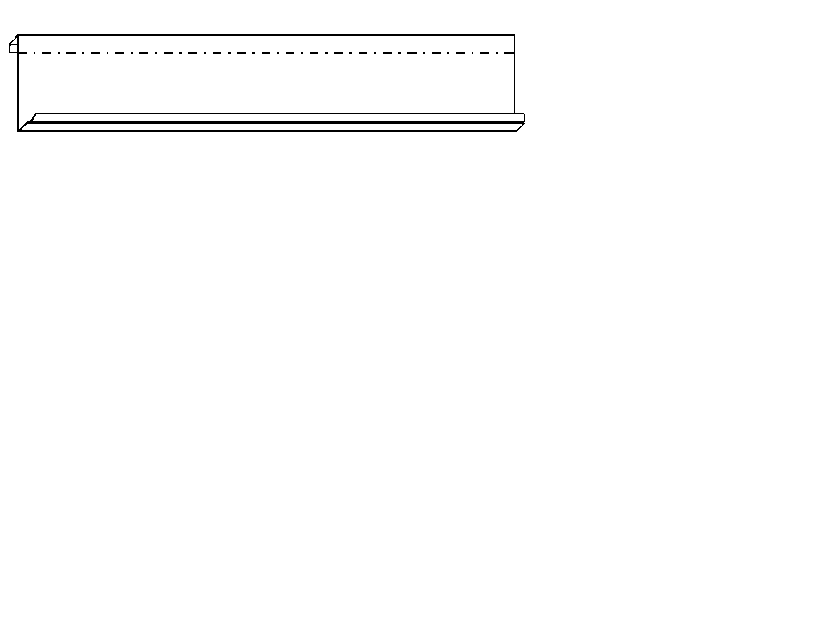

Large Flange Leg

Small Flange Leg

A | B | C | D | E | F

Punching  Length | A | B | C | D | E | F

Customer Comments:

Customer Signature:
Company:

